NATIONAL RESEARCH UNIVERSITY
HIGHER SCHOOL OF ECONOMICS

Faculty of Computer Science
Bachelor’s Programme “Data Science and Business Analytics”

Programming Project Report on the Topic:

" Development of a Web Application for Portfolio Management"

Submitted by the students:
Kozlov Sergey Andreevich, БПАД231, 3d year of study
Bratukhin Nikita Alexeyevich, БПАД232, 3d year of study
Mamakia Ekaterina Vladimirovna, БПАД231, 3d year of study
Rodikov Maksim Dmitrievich, БПАД232, 3d year of study

Approved by the Project Supervisor:
Munerman Ilya Viktorovich
Moscow 2026

Content

Content 2
1. Annotation 3
2. Keywords 3
3. Introduction 3
4. Setting the task 5
5. Work completion plan 7
5.1 The main plan 7
5.2 Additional tasks 8
6. Overview of analogues 9
7. Project structure 12
7.1 Financial and mathematical aspect 12
7.1.1. Asset Return Calculation 12
7.1.2. Expected Return 13
7.1.3. Portfolio Return 13
7.1.4. Risk Measurement 14
7.1.5. Covariance 14
7.1.6. Correlation 14
7.1.7. Portfolio Variance (Matrix Form) 14
7.1.8. Markowitz Optimization Problem 15
7.1.9. Sharpe Ratio 15
7.1.10. CAPM Model 15
7.1.11. Inflation Adjustment 16
7.1.12. Monte Carlo Simulation 17
7.1.13. DCF Model 18
7.1.14. Gordon Growth Model 19
7.1.15. Black–Scholes Model 19
7.1.16. Value at Risk (VaR) 19
7.2 Data 19
7.2.1Portfolio Data Structure 19
7.2.2 Data sources 21
7.3 Backend 22
7.4 Frontend 24
8. References 26

1. Annotation

In Russian:
Проект направлен на разработку веб-приложения, предназначенного для управления инвестиционным портфелем, что позволит автоматизировать анализ и отслеживание финансовых активов.

In English:
The project is aimed at developing a web application for portfolio management that will automate the analysis and tracking of financial assets.

2. Keywords

Portfolio management, investments, finance, asset allocation, risk analysis, web application, data visualization, Python, JavaScript, React, PostgreSQL.

3. Introduction

In the modern financial landscape, individual investors and financial analysts often manage investment portfolios across multiple platforms and accounts. Currently, many resort to manual methods such as spreadsheets or basic tools to consolidate and monitor their investments, which is both time-consuming and prone to errors. The project aims to develop an advanced web-based software solution designed to significantly simplify and automate the process of tracking and analyzing investment portfolios. This system will enable users to oversee diverse assets (stocks, bonds, cryptocurrencies, etc.) in one place, taking into account crucial factors such as asset allocation, risk, return, and investment goals. By providing real-time data integration and analytical tools, the software will assist users in making informed decisions more quickly and with greater confidence. The project’s focus on portfolio management is highly relevant due to the growing need for efficiency, accuracy, and speed in financial decision-making, as well as the desire to minimize errors caused by manual data handling. The solution will help save time (and by extension, money) for investors by automating routine calculations and data aggregation tasks that were previously done by hand.

The project will deliver a flexible, efficient, and secure software solution that allows users to easily access their portfolio data, perform analysis, and generate reports in convenient formats. The intuitive web interface of the application will facilitate interaction for users who may not be experts in finance or technology, making portfolio management processes more transparent and understandable. The software will integrate with existing financial data systems and APIs, automatically fetching up-to-date information on market prices, asset values, and other key metrics. This automatic data collection (for example, retrieving stock prices, exchange rates, and transaction records) eliminates the need for users to manually input or update figures, thereby reducing the influence of the human factor on portfolio tracking accuracy. Key functionality of the software will include automated performance calculations, customizable reporting templates, and interactive data visualizations. Users will be able to create tailored reports—such as portfolio performance over a selected period, risk assessments, or asset allocation breakdowns—thanks to built-in tools that analyze the input data. The system can also provide suggestions, for instance recommending a rebalancing of the portfolio if certain asset classes deviate from target allocations; the user can then adjust these suggestions if they are not fully satisfied with the automated outcome. After finalizing an analysis or report, the user will have the option to either send the results to a printer or save them to their device in PDF or image format for future reference or sharing.

Data security is an important aspect of the project. The application will include a robust authorization system to manage user access rights and protect confidential financial information. Each user’s data will be secured through authentication measures (such as secure password storage and possibly two-factor authentication), and data transmission will be encrypted to prevent unauthorized access. Given the sensitivity of financial data, the system will enforce privacy and data protection best practices, ensuring that each user’s portfolio information is only accessible to them or authorized personnel. In addition, the project envisions ensuring mobile availability of the software. Users will be able to access their portfolio management dashboard through various devices, including smartphones and tablets, enabling them to stay informed about their investments and make timely decisions regardless of location. This cross-platform accessibility acknowledges the modern need for on-the-go access to financial information and contributes to faster response times in volatile markets. Overall, the introduction of this web application will bring a new level of efficiency and insight to portfolio management, aligning with current trends in fintech and personal finance management to provide a user-friendly yet powerful tool for investors.

4. Setting the task

The main task is to create an easy-to-use interface for managing an investment portfolio, which will operate as follows: First, the user must log in to ensure data security and personalized access. After logging in, the user is presented with a main dashboard page that contains an overview of their portfolio and clearly labeled options for what can be done on the site. From the dashboard, the user can navigate to features such as Add Asset, View Portfolio, Analyze Portfolio, or Generate Report.

One core feature is the ability for the user to add any financial asset to their portfolio database with all the necessary details. When adding an asset, the user will specify attributes such as the asset type (e.g., stock, bond, ETF, cryptocurrency), ticker or identifier, quantity owned, purchase price, purchase date, and any relevant classification (sector, asset class, region, etc.). All assets in the system will be organized into categories (for example, stocks by industry sector, bonds by issuer type, etc.), which will make searching and filtering through one’s portfolio simple and fast. The application will also support importing asset data in bulk – for instance, the user might upload a file with transactions or connect to a brokerage account via an API – to automatically populate the portfolio with minimal manual input. The system will convert any imported data into the required format and integrate it into the portfolio database.

When working in the Portfolio View interface, the application provides a comprehensive visualization of the portfolio’s status. On one side of the screen, the user will see summary information such as total portfolio value, current profit or loss, and overall return percentage. This section may include charts (pie charts or bar charts) showing the asset allocation (how much of the portfolio is in stocks vs. bonds vs. other assets) and performance over time (a line graph of portfolio value or returns). On the other side of the screen, a detailed list or table of the individual assets is displayed, including columns for asset name, current market price, quantity, total value, daily change, and percentage of the portfolio. This full breakdown is updated in real-time (or on-demand) by fetching market data for each asset. The interface may allow toggling between a Summary view (for a high-level outlook) and a Detailed view (showing each holding and transaction history).

In the Analysis or Planning section of the application, the user can select tools to evaluate their portfolio’s risk and return profile. For example, the user might use a “What-if” simulator – adjusting the composition of the portfolio on a virtual sandbox to see how adding or removing a certain asset would have impacted performance or risk. The system could calculate key indicators such as the portfolio’s expected annual return, volatility (standard deviation of returns), Sharpe ratio, and other metrics based on historical data. The user can input parameters (for instance, “target an overall 10% return with minimal risk” or “assume an economic scenario X”) and the system will model outcomes accordingly. If integrated with external libraries or services, the application might also implement optimization algorithms (for example, using principles of Modern Portfolio Theory to suggest an optimal asset weight distribution for maximizing return at a given risk level). The results of these analyses would be presented in a user-friendly format – for instance, highlighting which assets contribute most to risk, or how the portfolio’s performance compares to a benchmark index. The user can iteratively adjust their portfolio within this tool to approach a desired balance, then choose to implement those changes in the actual portfolio.

Throughout the interface, the system provides helpful visual cues and data summaries. For example, if the portfolio contains stocks on multiple shelves (markets) or categories, the application could display separate charts per category (similar to how the example of shelves was described in the rack design project – here analogously, one might imagine separate sections for different account types or goals). For each category or account, the system can show the total value and profit/loss, much like the “total weight of each shelf” in the prepack scenario was shown. This helps users quickly identify which segment of their portfolio is performing well or which is lagging.

The application also offers a Report Generation feature. After the user has arranged their data and possibly run analyses, they can generate a formal report document that encapsulates the key information about the portfolio. For instance, a report might include the portfolio’s current value, return over various periods (1 month, 6 months, 1 year), a snapshot of the asset allocation, and specific observations such as “Portfolio is overweight in technology stocks by 5% compared to target allocation” or “Portfolio volatility is below benchmark volatility by 2%”. The user can customize which sections to include in the report and add commentary if needed. The final report can be exported to PDF or an image format (PNG/JPG) for easy sharing or printing. The interface for report generation will allow the user to preview the report (showing charts and tables neatly formatted) before saving or printing. This is analogous to how in the rack design project, the final layout could be converted to PNG/PDF – here we convert the financial analysis into a presentable document for stakeholders or personal records.

5. Work completion plan

5.1 The main plan
For the successful implementation of the project, we have divided the development tasks among our team members. Below are the names of the team members and the list of their primary responsibilities:
Maxim Rodikov: leading the front-end development of the web application. Maxim is responsible for designing and implementing the React-based user interface, including the main dashboard, data input forms, and portfolio management pages. He will develop interactive visualizations (such as charts for asset allocation and performance tracking) and ensure smooth integration with the backend API. Maxim will focus on usability, responsiveness, and correct client-side behavior.
Sergey Kozlov: developing the backend logic and API of the application. Sergey will implement the server-side components (for example, using Python frameworks such as Django/Flask or Node.js), handling user requests, processing business logic, and performing portfolio-related calculations. He will design and maintain a RESTful API for communication with the front-end, ensure proper validation and error handling, and integrate external financial data sources (e.g., market APIs) into the system.
Nikita Bratukhin: setting up and managing the database infrastructure. Nikita will design the database schema (using PostgreSQL or a similar DBMS), implement data models, and ensure reliable storage of user and portfolio data. He will be responsible for query optimization, data integrity, indexing, and overall database performance. Nikita will also manage all database-related operations and ensure stable interaction between the backend and the database.
Ekaterina Mamakina: focusing on financial analytics and supporting backend functionality. Ekaterina will implement financial analysis modules, including portfolio performance metrics and risk indicators. She will contribute to backend-related data processing tasks, assist with database operations where financial analysis is involved, and participate in testing and validation of analytical calculations to ensure their correctness and reliability.

5.2 Additional tasks

After creating the initial version of the service with core functionality, the team has outlined a few enhancements to further improve the application. First, we plan to strengthen the security and reliability of the system by introducing advanced authorization features. This includes implementing two-factor authentication for user logins to provide an extra layer of security, as well as fine-grained user permission control in case the application is extended for use in a team or enterprise environment (for example, distinguishing between a read-only analyst role and an administrator role who can make portfolio changes). We also consider adding robust audit logging—recording user actions like logins, data imports, or transactions—so that any changes in the portfolio can be traced back to the user and time of action. These measures will protect confidential financial data and build user trust in the application’s handling of sensitive information.

Secondly, we would like to extend the system’s analytical capabilities by integrating an intelligent recommendation engine. In future updates, we plan to incorporate a module that uses historical data and machine learning or algorithmic models to provide investment insights. For instance, using the Monte Carlo simulation method or Modern Portfolio Theory algorithms, the system could simulate thousands of possible portfolio outcomes to recommend an optimal asset allocation that maximizes return for a given risk level. The engine might also track market indicators and news sentiment to alert users of potential risks or opportunities (for example, suggesting the user to rebalance if the portfolio’s risk has increased due to market volatility). Another enhancement under consideration is a mobile application or a fully responsive web design that ensures a seamless experience on smaller screens. While the current project ensures the web interface is mobile-friendly, a dedicated mobile app could leverage native features like push notifications to alert users about important events (such as a significant change in portfolio value or achievement of a milestone). Implementing these additional tasks will further increase the value of our software, offering users not just a static tracking tool but a proactive assistant in managing their investments.

6. Overview of analogues

When searching for existing solutions and conducting a comparative analysis, we found that many individual investors still rely on general-purpose tools like spreadsheet software (e.g., Microsoft Excel or Google Sheets) to manage their portfolios. Let’s compare our project with the traditional approach of using spreadsheets for portfolio management.
1. Goals and functionality: Our project is a specialized solution aimed at automating portfolio tracking and analysis, offering features specifically designed for investment management (such as automatic price updates, risk calculations, and portfolio rebalancing recommendations). In contrast, a spreadsheet is a general tool with no built-in finance-specific functionality; any portfolio tracking must be set up manually by the user. Modern portfolio management platforms emphasize moving beyond spreadsheets for tracking investments, underlining that spreadsheets are not purpose-built to handle the complexity of diverse assets. Our application provides an integrated environment where all necessary tasks (data collection, computation, and visualization) are handled seamlessly, whereas spreadsheets require significant user effort to achieve similar outcomes.
2. Ease of use: The web application we propose offers an intuitive interface tailored for portfolio management, meaning even users with minimal technical or financial background can navigate dashboards, input data, and interpret charts with ease. It provides forms, buttons, and visual aids specifically for common tasks like adding assets or viewing performance. On the other hand, using spreadsheets for portfolio management can be less user-friendly; effective use requires knowledge of formulas, cell referencing, and possibly scripting. Spreadsheet users must design their own layout and calculations, which can be confusing and may lead to mistakes if the user is not highly experienced. Our project is aimed at an end user who might have limited expertise, allowing them to manage investments without dealing with the complexities of spreadsheet formulas or debugging errors, whereas the spreadsheet approach often assumes a higher skill level and more effort from the user.
3. Integration with data sources: A key advantage of our project is its integration with financial data feeds and APIs. The application automatically retrieves current stock prices, currency exchange rates, and other asset data, updating the portfolio in real time. It can also connect to brokerage accounts or import transaction files for seamless data ingestion. In contrast, spreadsheets have no native data integration – users typically must manually enter data or use complex workarounds (like Excel’s web queries or Google Sheets functions) for each update. This manual data handling in spreadsheets not only takes time but also risks accuracy, as formulas might break or data might become outdated. Because of fragile formulas and disconnected data, reliable reporting is often impossible across multi-asset spreadsheets. Our system’s automatic data integration reduces these issues by ensuring consistency and accuracy of information without requiring the user to perform repetitive copy-paste or uploads.
4. Efficiency and economic benefits: The specialized portfolio management app increases efficiency by significantly reducing the time needed to maintain and analyze a portfolio. Tasks that might take hours in a spreadsheet (such as updating prices, recalculating metrics, generating charts) are done in seconds or automatically in our application. This speed-up allows users to focus more on decision-making rather than data upkeep. Moreover, by minimizing human error (for example, avoiding mistakes in formula editing or data entry), our software improves the reliability of the results – an error in a spreadsheet could lead to incorrect decisions, whereas our system’s automated calculations are less error-prone. While spreadsheets themselves are low-cost or already available to many users, the hidden cost is the manual labor and expertise required to use them effectively. In a business context, the time saved by our application can translate into economic benefits: faster reaction to market changes and fewer losses due to oversight. Industry analyses have noted that relying on spreadsheets for complex portfolios leads to slower reporting and even erodes data integrity over time. By contrast, our integrated tool provides timely and accurate insights, directly contributing to better financial outcomes for the user.
5. Relevance and security: Our project puts a strong emphasis on data security and proper user access controls, which is especially important when dealing with confidential financial information. The application will have secure login, encrypted data storage, and audit trails for changes, aligning with modern security standards. Spreadsheet files, however, have minimal security; they can be easily copied, shared, or accidentally modified without any record. There is no straightforward way to restrict access (beyond file passwords which are often weak) or to track who made which change in a typical spreadsheet. For a professional or enterprise setting, this lack of security and accountability is a major drawback. Our application, by managing authentication and authorization, ensures that only authorized users can view or modify the portfolio, and every action can be logged. This level of security makes our solution more suitable for serious portfolio management, whereas spreadsheets pose risks of data leakage or loss (for example, a lost laptop with an open spreadsheet file, or an email with an attachment sent to the wrong person). In terms of relevance, as data privacy regulations become stricter, using a secure application is far more aligned with compliance requirements than ad-hoc spreadsheet tracking.
6. Support and customization: The proposed web application includes built-in support for portfolio-specific reporting and analysis, which can be customized through the interface. Users can tailor the outputs (such as choosing different report templates, setting their target asset allocation, or toggling which metrics to display on their dashboard) without needing to modify underlying code. If users need help or additional features, our project can be extended with plugins or updates, and we anticipate providing documentation and possibly user support forums for the system. In contrast, spreadsheets are highly flexible in theory – they can be customized in unlimited ways – but this requires the user to do all the customization themselves. There is no dedicated customer support or automatic updates for a self-made spreadsheet solution; the user must fix any issues or add new features manually. Additionally, spreadsheets might struggle to scale or adapt to very large portfolios or data volumes, whereas our application is designed to handle scalability (with a proper database and optimized code). Thus, while Excel/Sheets offer general-purpose flexibility, our solution offers targeted customization with far less effort on the user’s part.
7. Conclusion: Our project clearly offers substantial advantages over the spreadsheet-based approach for anyone focused on automating processes and reducing errors in portfolio management. The spreadsheet method has its place as a quick, ad-hoc tool, and it is familiar to many, but it does not deliver the integrated, robust functionality needed for comprehensive portfolio oversight. It lacks real-time data integration, advanced analytics, and the ease of use that our specialized web application provides. By integrating data sources, ensuring security, and providing user-friendly analytical tools, the proposed project better meets the needs of investors and analysts. It gives users tangible benefits in speed, convenience, and reliability that general spreadsheet solutions cannot easily match. In summary, while spreadsheets are universal and were once the go-to solution for tracking investments, our dedicated portfolio management software is a modern solution that addresses the shortcomings of the manual approach and empowers users to manage their assets more effectively.

7. Project structure

7.1 Financial and mathematical aspect

7.1.1. Asset Return Calculation
Simple Return
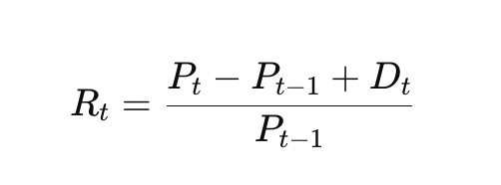
Where:
P_t is the asset price at time t
D_t is the dividend
Used to calculate the historical return of each asset, which is then applied in risk analysis, correlation, and portfolio optimization.
Logarithmic Return
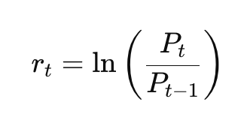
Logarithmic return is used in statistical modeling and Monte Carlo simulations because it has additive properties and is better suited for financial time series.

7.1.2. Expected Return
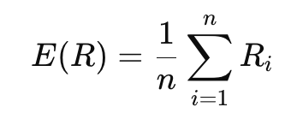
Determines the average historical return of an asset. Used in the portfolio optimization model and when constructing the efficient frontier.

7.1.3. Portfolio Return
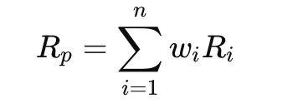
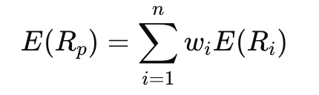
where w_i is the share of the asset in the portfolio.
Allows the system to calculate the total expected return of the portfolio depending on the asset structure.

7.1.4. Risk Measurement
1) Variance
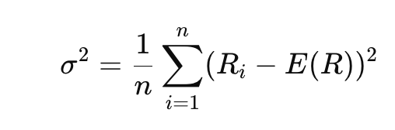
2) Standard Deviation
σ = √σ²
Standard deviation is used as the primary risk measure in the Markowitz model and when calculating the Sharpe ratio.

7.1.5. Covariance
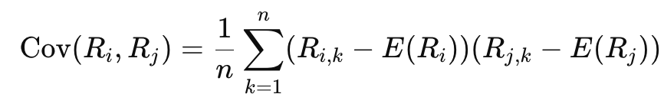
Determines how two assets move relative to each other. Used to construct the portfolio covariance matrix.

7.1.6. Correlation
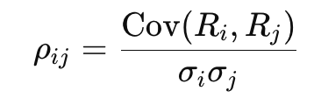
Allows the system to find assets with low correlation to improve diversification and reduce systemic risk.

7.1.7. Portfolio Variance (Matrix Form)
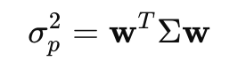
where
w is the weight vector
Σ is the covariance matrix
This is the central formula of Modern Portfolio Theory. Based on it, the system calculates the total portfolio risk and constructs the efficient frontier.
More detailed formula is the following:
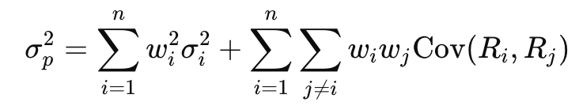

7.1.8. Markowitz Optimization Problem
min wᵀ Σ w
Subject to:
Σ w_i = 1
E(R_p) = R_target
The theory was developed by Harry Markowitz.
Allows automatic calculation of optimal asset weights to achieve minimal risk for a given return.

7.1.9. Sharpe Ratio
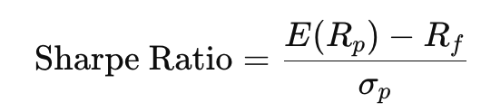
where R_f is the risk-free rate.
Used to evaluate portfolio performance taking into account risk. Allows comparison of different strategies.

7.1.10. CAPM Model
Beta
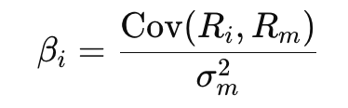
Expected Return (CAPM)
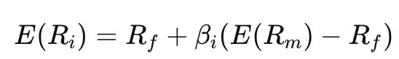
Used to evaluate the required return on an asset taking into account its market risk.
How it works:
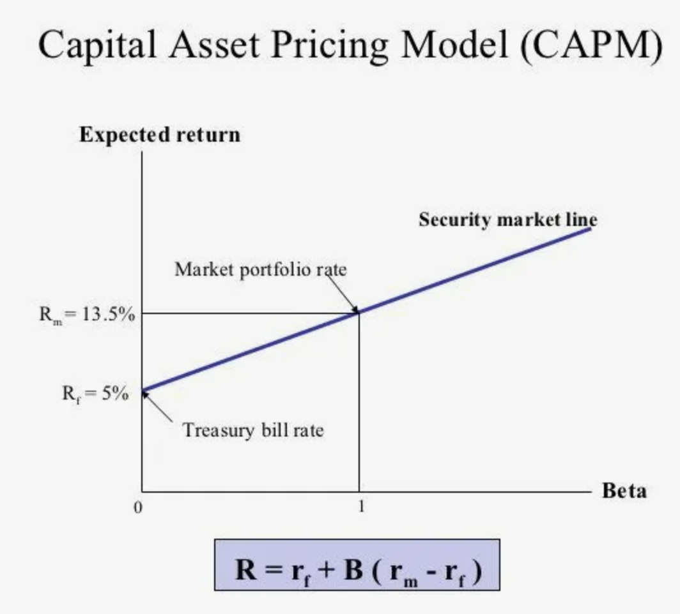

7.1.11. Inflation Adjustment
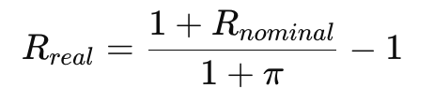
where π is the inflation rate.
Allows you to calculate the real return of a portfolio taking into account currency depreciation.

7.1.12. Monte Carlo Simulation
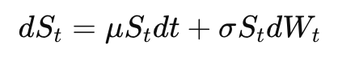
Discrete model:
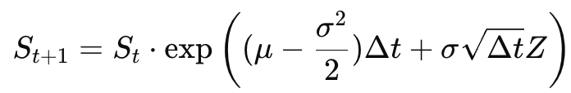
where Z ~ N(0.1)
The method is described in detail in Habr materials.
Used to simulate thousands of possible scenarios for the future value of a portfolio and assess the probability of achieving the target return.
Visualization:
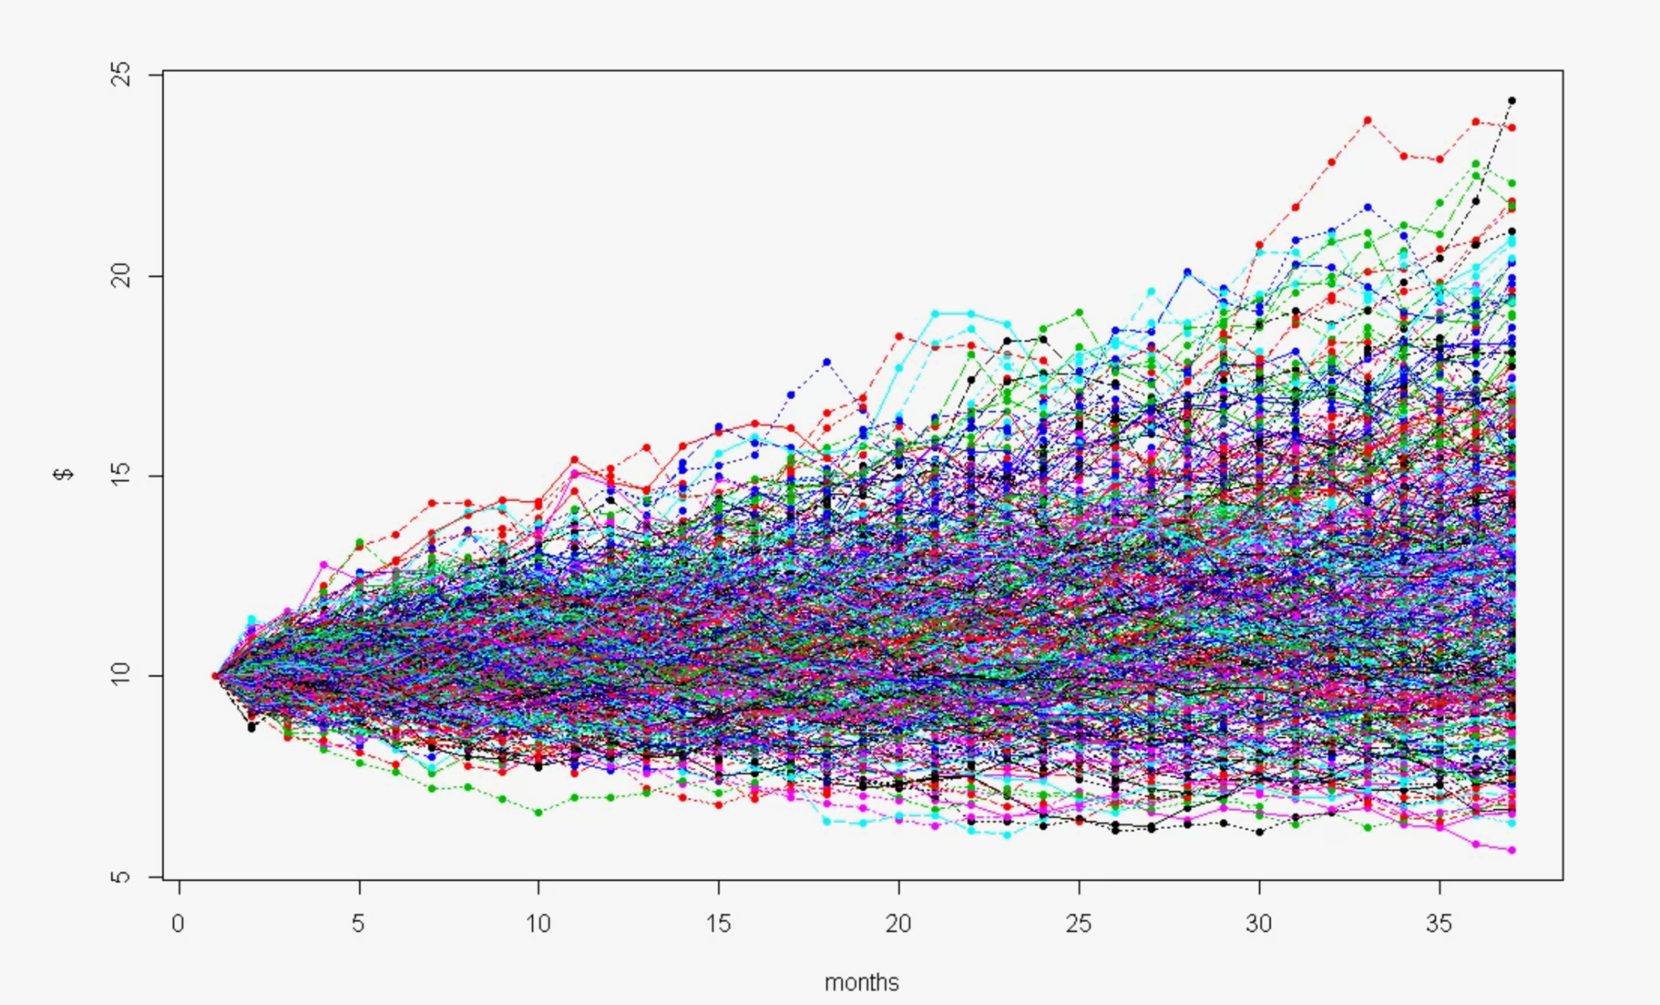
This is the brownian motion of sample, as we assume, that the prices movements are random
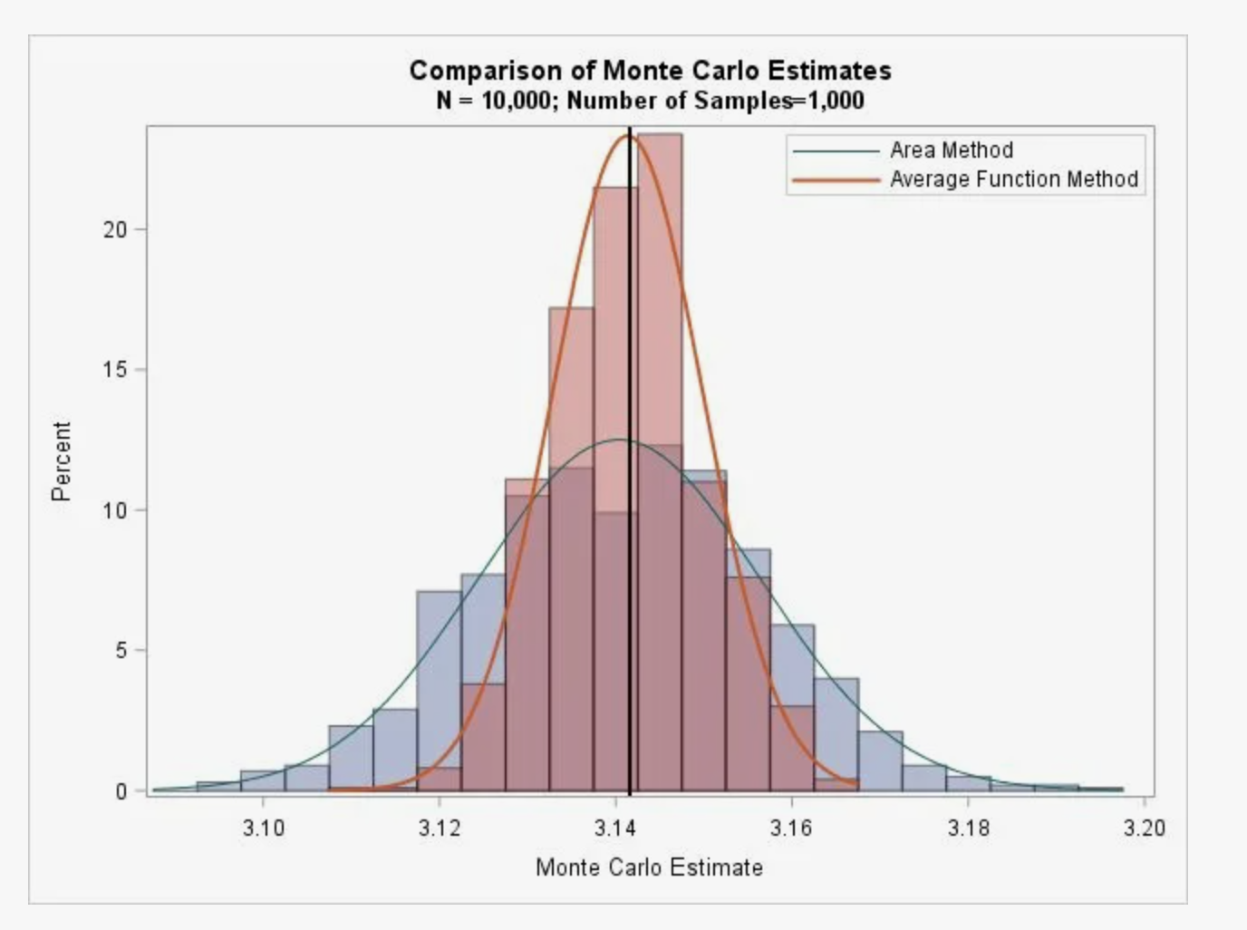
Here is how usually the result of Monte Carlo Estimate look like on this kind of samples.

7.1.13. DCF Model
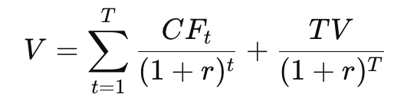
Terminal Value:
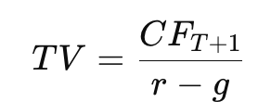
Used to determine the fundamental value of stocks and identify undervalued assets.

7.1.14. Gordon Growth Model
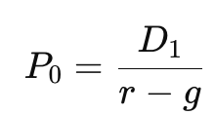
Used to value dividend-paying companies as part of a multi-model valuation.

7.1.15. Black–Scholes Model
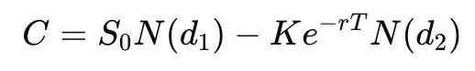
where
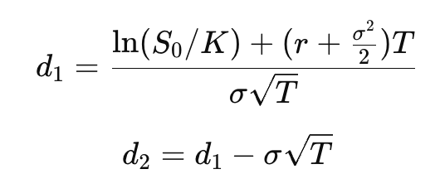
Allows you to calculate the fair price of an option for portfolio risk hedging strategies.

7.1.16. Value at Risk (VaR)
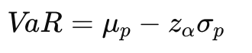
Used to estimate the maximum expected loss of a portfolio at a given confidence level.

7.2 Data

7.2.1Portfolio Data Structure
The system is built around a centralized database containing the following key entities:
- User
user_id
email
hashed_password
role (admin, analyst, read-only)
2FA_status
- Asset
asset_id
asset_type (stock, bond, ETF, crypto, derivative)
ticker
sector
region
currency
- Transaction
transaction_id
asset_id
quantity
purchase_price
purchase_date
- Portfolio Snapshot
-total_value
-total_return
-inflation_adjusted_return
-volatility
-sharpe_ratio
- Market Data
-historical_prices
-dividend_yield
-risk_free_rate
-Current_price
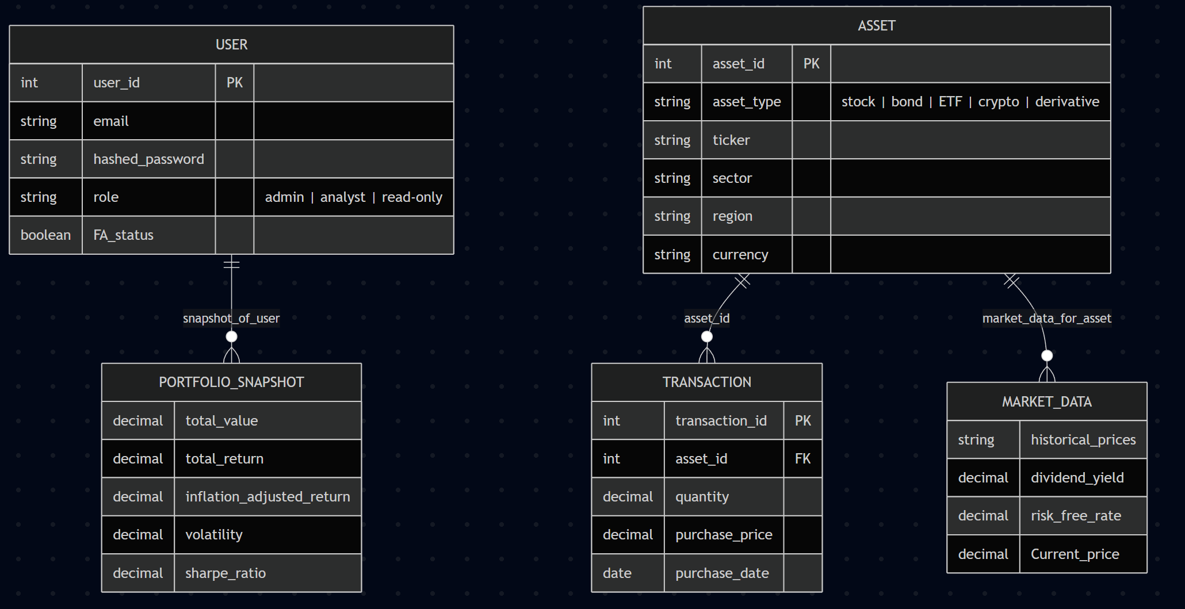

7.2.2 Data sources
The primary external data source used in the system is the T-Invest API, a gRPC-based public interface provided by T-Bank for interaction with the T-Investments trading platform. The API provides free access to market and portfolio data and supports both unary requests and streaming mechanisms. Within the framework of this project, T-Invest API serves as the main provider of financial market information and portfolio-related data.
The system retrieves current market quotes and historical price series through the API. Historical data is required for calculating asset returns, volatility, covariance and correlation matrices, Sharpe ratio, Value at Risk (VaR), and for performing Monte Carlo simulations and Markowitz portfolio optimization. Real-time price streaming enables dynamic updates of portfolio valuation and supports live visualization in the frontend interface.
In addition to market data, the API provides access to portfolio composition, executed operations, and transaction history. These data streams are used to populate internal database entities such as Transaction and to compute derived metrics stored in Portfolio Snapshot, including total portfolio value, total return, inflation-adjusted return, volatility, and Sharpe ratio. Instrument reference data (identifiers, tickers, instrument characteristics) is used to correctly map portfolio positions to financial instruments in the system database.
Interaction with the T-Invest API requires an access token. For development and testing purposes, the sandbox environment is used, which allows algorithm verification without affecting real trading accounts. In production scenarios, the system can operate with a production token. All API interactions are performed exclusively on the backend layer; the access token is never exposed to the client side. The backend communicates with the API via secure gRPC connections, processes and normalizes incoming data, and stores validated information in the centralized PostgreSQL database.
Due to the presence of API rate limits and possible network instability, the system implements request management mechanisms, including caching of frequently requested market data, controlled request frequency, and retry logic for transient errors. Retrieved data is timestamped and standardized to ensure consistency across analytical modules. Internally calculated indicators derived from API data are persistently stored to enable report generation, historical comparison, and reproducibility of analytical results.

7.3 Backend
The backend of the system is implemented as a multi-layered modular architecture designed to ensure scalability, maintainability, and clear separation of responsibilities. The architecture follows the principle of layered abstraction, where each layer performs a strictly defined role and interacts only with adjacent layers. This structure enables independent development, testing, and extension of system components without modifying the core logic.
At the outer boundary of the backend lies the API Layer (Presentation Layer), which provides interaction between the frontend and backend via a RESTful API over HTTP using JSON as the data exchange format. This layer is implemented using FastAPI and is responsible for request routing, input validation, authorization verification, response serialization, and centralized error handling. The API layer exposes endpoints such as authentication (/login), portfolio retrieval (/portfolio), optimization (/optimize), simulation (/simulate), and report generation (/report). It does not contain business logic; instead, it delegates all computational and domain-specific operations to the service layer. API versioning and structured logging are implemented to ensure backward compatibility and traceability of requests.
The core of the system is the Service Layer (Business Logic Layer). This layer implements all financial, analytical, and domain-specific computations. It includes modules responsible for return calculation, volatility and risk estimation, Markowitz portfolio optimization, Monte Carlo simulation, inflation adjustment, Value at Risk (VaR) estimation, CAPM-based calculations, Black–Scholes option pricing, and fundamental valuation models such as DCF and the Gordon Growth Model. The service layer aggregates raw market and portfolio data, transforms it into analytical structures (e.g., covariance matrices, return vectors), and produces derived metrics stored in the Portfolio Snapshot entity. Each functional domain is encapsulated in an isolated service module (e.g., PortfolioService, RiskService, OptimizationService, SimulationService, ValuationService), which simplifies testing and future expansion of analytical functionality.
The Data Access Layer (Repository Layer) is responsible for interaction with the PostgreSQL database. It manages persistent storage of the entities defined in Section 7.2.1, including User, Asset, Transaction, Portfolio Snapshot, and Market Data. The system follows the ORM (Object–Relational Mapping) approach, which allows working with domain objects rather than writing raw SQL queries directly. This layer ensures data consistency, transaction management, and efficient querying. Redis is used as a caching mechanism for frequently requested market data and temporary session-related information, reducing database load and improving response time.
The Integration Layer provides controlled interaction with external services. Its primary responsibility is communication with the T-Invest API via gRPC. This layer retrieves current quotes, historical price series, instrument metadata, and portfolio operations data from both sandbox and production environments. It implements asynchronous data loading, normalization of external data formats into the internal schema, handling of API rate limits, retry mechanisms with exponential backoff, and error management. Market data received from the external API is timestamped, validated, optionally cached, and stored in the centralized database before being passed to analytical modules.
The Security Layer operates across all other layers and enforces system-wide protection mechanisms. It implements JWT-based authentication, role-based access control (RBAC), two-factor authentication support, secure password storage, and audit logging of user actions. Backend-level protections include input validation, prevention of SQL injection through ORM usage and parameterized queries, and secure handling of access tokens used for external API communication. All sensitive operations are logged to ensure traceability and compliance with best practices in financial data management.
This layered logical architecture ensures a strict separation between presentation, computation, persistence, integration, and security concerns. As a result, the backend system remains modular, extensible, and aligned with both quantitative financial modeling requirements and modern software engineering standards.

7.4 Frontend
The frontend of the application is designed as an interactive web platform focused on intuitive portfolio management, analytical clarity, and responsive user experience. Its primary objective is to provide structured visualization of financial data while minimizing cognitive load and maintaining ease of navigation. The interface follows a data-driven design principle, meaning that all visual components dynamically update based on data received from the backend via a REST API. The architecture is component-based (implemented using React/Next.js), which ensures separation between presentation and logic, promotes reuse of interface elements, and supports long-term scalability of the system.
The application begins with an authentication layer that includes login, registration, and optional two-factor verification. After successful authorization, the user receives a JWT token used for secure API communication. Once authenticated, the user is directed to the Dashboard, which serves as the central control panel of the system. The dashboard provides a high-level portfolio overview without overwhelming the user with excessive detail. It includes a top navigation bar displaying the username, current total portfolio value, and daily performance indicator, along with access to settings. A quick analytics section presents key indicators such as total portfolio value, total profit or loss, inflation-adjusted return, and Sharpe ratio. Quick-action controls allow the user to add assets, import transaction data, initiate analytical calculations, or generate a report, thereby ensuring efficient workflow navigation.
The Portfolio View interface combines summary analytics with detailed holdings information in a structured layout. Visual components include asset allocation charts, sector distribution diagrams, and price dynamics graphs. Core risk indicators such as volatility, beta, Value at Risk (VaR), and correlation heatmaps are displayed to support quantitative assessment. Users can adjust the time horizon for analysis (e.g., 1 month, 6 months, 1 year, 5 years, or a custom range), enabling flexible evaluation of portfolio behavior over different periods. Alongside graphical summaries, an interactive table provides granular information about each asset, including type, price, quantity, total value, daily change, and portfolio weight. The table supports sorting, filtering, searching by ticker, and data export. Selecting an asset opens a modal window with extended analytics such as historical performance charts, fundamental indicators, correlation with the overall portfolio, and valuation outputs (e.g., DCF-based estimates).
The Analytics and Planning section represents the most computationally intensive component of the interface and visualizes results produced by the backend’s quantitative models. It includes efficient frontier visualization and risk–return diagrams displaying the current portfolio position relative to optimal and minimum-variance portfolios. Users can adjust a risk preference parameter, triggering recalculation of asset weights and real-time updates of charts. The Monte Carlo simulation module allows users to define investment horizon, number of simulations, and return/volatility assumptions, with results presented as probability distributions, target achievement likelihood, and downside risk scenarios. A diversification scanner displays correlation matrices, highlights highly correlated assets, and generates recommendations aimed at reducing systemic risk.
The Report Generation module enables users to produce structured portfolio reports in PDF or image format. Users select the analysis period, define included sections, and preview the formatted output before export. Reports typically contain a title page, summary tables, graphical visualizations, and analytical commentary derived from portfolio metrics. The layout follows industry-standard reporting practices used in professional portfolio management tools.
From a UX perspective, the interface applies a consistent visual language to enhance clarity and interpretability. Color coding distinguishes positive and negative financial outcomes, typography emphasizes key metrics, and interactive elements such as tooltips, animated value updates, and dynamic chart rendering improve usability. The design follows responsive principles, adapting layout structure for desktop, tablet, and mobile environments. Desktop versions prioritize two-panel analytical layouts, while smaller screens reorganize components into vertically structured adaptive blocks. Future enhancements may include Progressive Web App capabilities and push notifications for real-time alerts.
Interface-level security measures complement backend protections by implementing automatic logout after inactivity, masking of sensitive information, and safeguards against XSS and CSRF attacks. The frontend technology stack includes React/Next.js for application structure, Tailwind CSS for styling, Chart.js or D3.js for data visualization, REST API integration for backend communication, and optional WebSocket connections for live data updates.

8. References
1. investopedia.com – Article titled “Best Portfolio Management Tools for 2026: Top Picks & Features” (https://www.investopedia.com/best-portfolio-management-software-tools-11693031)
2. habr.com – Article titled “Использование метода Монте-Карло для создания портфеля” (Using the Monte Carlo method for portfolio creation) (https://habr.com/ru/articles/500262/)
3. habr.com – Article titled “Отец современного инвестирования. Гарри Марковиц. Оптимальный портфель по Марковицу” (Father of modern investing. Harry Markowitz. Markowitz’s optimal portfolio) (https://habr.com/ru/articles/981108/)
4. assetvantage.com – Blog titled “Still Using Spreadsheets? How Family Office Portfolio Management Software Fixes the Blind Spots” (https://www.assetvantage.com/blogs/still-using-spreadsheets-how-family-office-portfolio-management-software-fixes-the-blind-spots/)
5. developer.tinkoff.ru – “Начало работы / What is T-Invest API” (https://developer.tinkoff.ru/invest/intro/intro)
6. swagger.io – “OpenAPI Specification” (https://swagger.io/specification/)
7. postgresql.org – “PostgreSQL Documentation” (https://www.postgresql.org/docs/)

